PROJECT REPORT OF INDUSTRY ORIENTED HANDS ON EXPERIENCE (IOHE)
ON
Evolution of Electric Vehicles and the Role of Artificial Intelligence in Future Electric Mobility

submitted in partial fulfilment of the requirements for the award of degree of

BACHELOR OF ENGINEERING
In
COMPUTER SCIENCE AND ENGINEERING

Submitted by: Supervised By:
Shashwat Rana Dr. Preeti Saini
Roll Number 2210992291


DEPARTMENT OF COMPUTER SCIENCE AND ENGINEERING

CHITKARA UNIVERSITY INSTITUTE OF ENGINEERING AND TECHNOLOGY
CHITKARA UNIVERSITY, PUNJAB, INDIA

CONTENTS

S.No. | Title | Page No.
 | Abstract | 4
1 | Introduction | 5
2 | Methodology | 7
3 | Evolution | 7-8
4 | Roles | 10
5 | Conclusion and Future Scope | 14
6 | References | 15

DECLARATION

I hereby certify that the work which is being presented in the project report entitled “Evolution of Electric Vehicles and Role of AI in Future Electric Mobility” in partial fulfilment of requirement for the award of the degree of Bachelor of Engineering (Computer Science and Engineering) submitted in the department of Computer Science and Engineering at Chitkara University Institute of Engineering and Technology, Chitkara University, Punjab, India, is an authentic record of my own work carried out under the supervision of Dr. Preeti Saini. The matter presented in this project report has not been submitted in any other university/institute for the award of any degree.

Place: Rajpura Shashwat Rana
Date: …………….. University Roll No. 2210992291

This is to certify that the above statement made by the candidate is correct to the best of my knowledge and belief.

Dr. Preeti Saini
Department of Computer Science and Engineering
Chitkara University Institute of Engineering and Technology,
Chitkara University, Punjab, India

Abstract
Electric vehicles (EVs) have emerged as one of the most encouraging solutions for minimizing greenhouse gas emissions and reliance on fossil fuels in the transportation sector. Over the past century, EV technology has evolved from easy and straightforward battery-powered prototypes to extremely advanced vehicles equipped with intelligent systems and high-capacity batteries. The quick and fast decrease in lithium-ion battery costs and improvements in energy density have considerably accelerated the adoption of EVs globally. In latest and current years, artificial intelligence (AI) has played a critical and vital role in transforming electric vehicles into intelligent mobility systems. AI technologies such as machine learning, neural networks, and predictive analytics are broadly used in battery management systems, autonomous driving, predictive upkeep, and intelligent charging system. This study inspects the historical evolution of electric vehicles and explores the impact of artificial intelligence on the future of electric mobility. The study is established on a complete and thorough review of academic study, sector reports, and technological developments in the EV sector. The results suggest that AI-driven technologies considerably enhance energy productivity, vehicle safety, and operational performance. Furthermore, the integration of AI with EV technology will permit the development of autonomous electric transportation systems and smart mobility networks. The study concludes that the combination of electric mobility and artificial intelligence will play a vital role in forming sustainable transportation systems in the future.

Keywords: Electric Vehicles, Artificial Intelligence, Battery Technology, Smart Mobility, Autonomous Vehicles, Sustainable Transportation.

Introduction
The worldwide transportation sector is undergoing an important and significant transformation due to growing environmental concerns, rising fuel prices, and the need for sustainable mobility solutions. Traditional internal combustion engine (ICE) vehicles depend heavily on fossil fuels, which contribute considerably to greenhouse gas emissions and environmental pollution. As a result, electric vehicles have gained worldwide attention as an environmentally friendly option to traditional vehicles.
Electric vehicles are powered by electric motors and rechargeable batteries instead of gasoline or diesel engines. These vehicles generate zero tailpipe emissions and offer greater energy productivity compared to traditional vehicles. According to worldwide sector data, electric vehicle sales reached more than 14 million units in 2023, representing approximately 18% of total worldwide car sales.
The evolution of electric vehicles has been driven largely by improvements in battery technology. Lithium-ion batteries, which are the most commonly used energy storage systems in EVs, have experienced dramatic cost decreases over the past decade. The cost of lithium-ion batteries fell by almost 90% between 2010 and 2020, substantially enhancing the affordability of EVs.
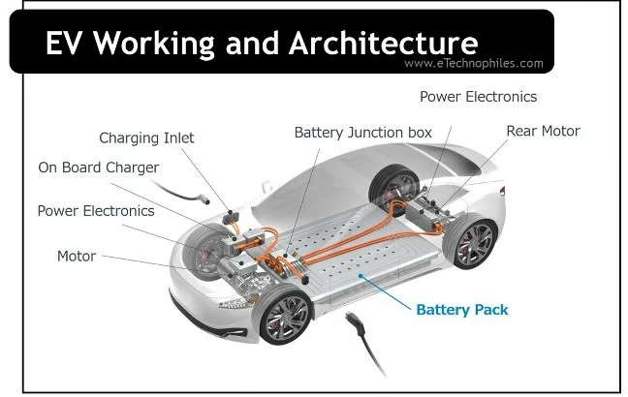
Figure 1: Electric Vehicle Architecture
(Source : www.etechnophiles.com)
At the identical time, artificial intelligence has emerged as a revolutionary technology in the automotive sector. AI technologies allow intelligent decision-making, predictive analytics, and autonomous driving abilities. In electric vehicles, AI is broadly used for energy optimization, battery tracking, route planning, and driver support systems.
This study concentrates on analysing the evolution of electric vehicles and examining how artificial intelligence is shaping the development of next-generation electric mobility systems.

Literature review
Numerous researchers have examined the technological evolution of electric vehicles and the growing role of artificial intelligence in the automotive sector.
Studies on EV battery development show that lithium-ion battery technology has played a central role in the expansion of the electric vehicle sector. Continuous improvements in battery chemistry and production procedures have increased energy density while considerably minimizing costs. These improvements have permitted modern EVs to achieve driving ranges surpassing 400 miles on a single charge.
Industry reports show that lithium-ion battery prices have reduced substantially due to advancements in battery chemistry, economies of scale, and improvements in production technologies. By 2023, the typical lithium-ion battery price fell to approximately $139 per kWh, facilitating EV manufacturers to generate more reasonable vehicles.
Recent inquiry moreover highlights the significance of artificial intelligence in electric vehicle systems. Machine learning algorithms are increasingly used to approximate battery state-of-charge and state-of-health, allowing better battery performance and enhanced safety.
Another area of study concentrates on AI-based energy management methods in electric vehicles. Reinforcement learning techniques such as Q-learning have been displayed to reduce battery deterioration and improve energy productivity by optimizing power distribution between distinct vehicle components.
Despite these advancements, researchers continue to explore new battery technologies and intelligent transportation systems to further enhance the performance and sustainability of electric vehicles.

Research objective
The primary objectives of this study are:
1. To study the historical evolution of electric vehicles.
2. To examine technological advancements in EV battery and powertrain systems.
3. To examine the role of artificial intelligence in electric vehicle technology.
4. To evaluate the future potential of AI-driven electric mobility systems.

Research Hypothesis
H1: Artificial intelligence considerably improves the productivity and performance of electric vehicles.
H2: AI-based systems enhance battery management and predictive upkeep in EVs.
H3: Integration of AI technologies will accelerate the worldwide adoption of electric mobility.

Research Methodology
This study uses a secondary inquiry methodology established on analysis of existing literature, sector reports, and academic publications related to electric vehicles and artificial intelligence.
The study methodology includes the following steps:
1. Collection of secondary data from academic journals, inquiry papers, and sector reports.
2. Analysis of historical benchmarks in electric vehicle development.
3. Examination of artificial intelligence applications in EV technology.
4. Comparative analysis of technological trends and future developments in the EV sector.
Data sources contain reports from energy organizations, academic inquiry publications, and sector datasets related to EV adoption and battery technologies.

Evolution of Electric Vehicle
1. Early Development of Electric Vehicles
The idea of electric vehicles dates back to the initial 19th century. The first experimental electric vehicles were developed in the 1830s utilizing initial battery technologies. By the late 1800s, electric cars were popular in urban areas because they were quiet, simple and straightforward to work, and produced no exhaust emissions.

Figure 2: Early Electric Vehicle Prototype (19th Century)
Figure 2 shows the images of Thomas Edison and George Meister in a Studebaker electric runabout, 1909.
2. Decline of Electric Vehicles
Despite initial appeal, electric vehicles declined during the initial 20th century due to various aspects:
2.1 Limited battery capability
2.2 High production costs Development of gasoline engines
2.3 Mass production of internal combustion vehicles
The introduction of reasonable gasoline vehicles considerably reduced the demand for electric cars.
3. Revival of Electric Vehicles
Interest in electric vehicles revived in the late 20th century due to environmental concerns and oil crises. Governments and automotive firms started investing in electric vehicle study and development. Technological advancements in battery systems and power electronics further accelerated EV development.
4. Modern Electric Vehicle Era
The modern era of electric vehicles started after 2010, with notable improvements in battery technology and charging system. Global EV sales have increased swiftly, reaching over 17 million units in 2024 and proceeding to grow quickly internationally.
Key technological advancements contain:
4.1 Lithium-ion battery systems
4.2 Fast charging technologies
4.3 Electric powertrain systems
4.4 Smart battery management systems
4.5 Connected vehicle technologies
These innovations have transformed electric vehicles into extremely productive and intelligent transportation systems.
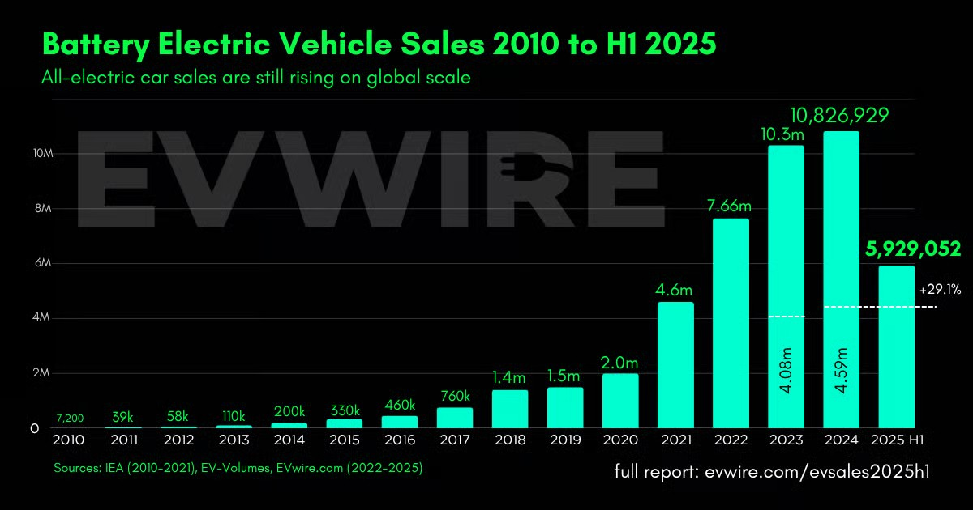Figure 3: Global Electric Vehicle Sales Growth (2010–2025)
Figure 3 shows the rapid growth in global electric vehicle sales over the past decade due to improvements in battery technology, government incentives, and growing environmental awareness.

Role of Artificial Intelligence in Electric Vehicles
Artificial intelligence plays a crucial role in enhancing the performance, safety, and productivity of electric vehicles.
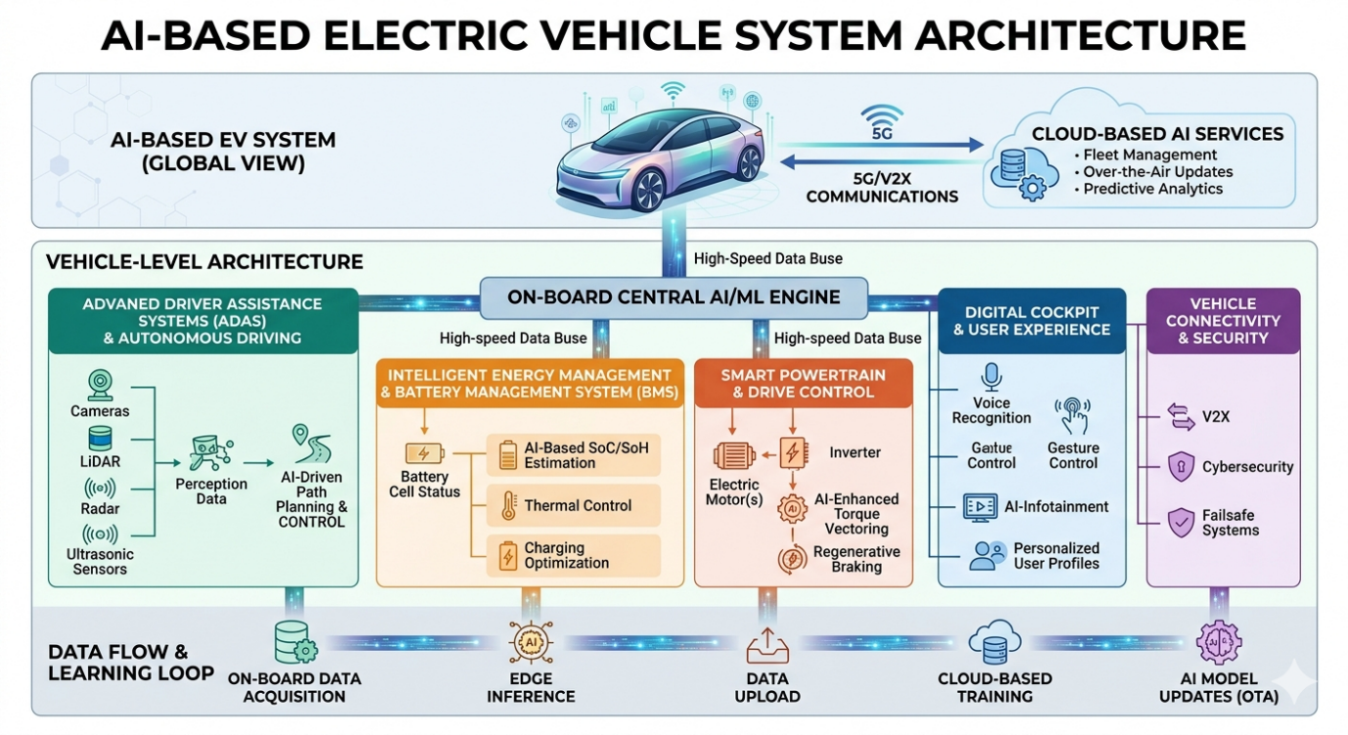Figure 4: AI-Based Electric Vehicle System Architecture
1. AI in Battery Management Systems
Battery management systems (BMS) is vital and crucial for observing battery performance and guaranteeing safe operation. AI algorithms examine huge and massive datasets from battery sensors to approximate battery condition, predict charging cycles, and optimize energy application. Machine learning models can precisely approximate battery state-of-charge and state-of-health, enhancing battery lifespan and minimizing upkeep costs.
2. Autonomous Driving Systems
Artificial intelligence is an essential technology behind autonomous vehicles. AI systems employ computer vision, deep learning, and sensor fusion to detect barriers, recognize traffic signals, and navigate road environments. Autonomous EVs have the potential to considerably reduce traffic accidents and improve transportation productivity.
3. Predictive Maintenance
AI systems examine vehicle performance data to detect potential component failures before they occur. Predictive upkeep reduces downtime, improves dependability, and lowers upkeep costs.
4. Energy Optimization
AI algorithms optimize energy consumption in electric vehicles by analysing driving patterns, road conditions, and traffic data. These systems help improve vehicle range and reduce energy garbage.
5. Intelligent Charging Infrastructure
Artificial intelligence is furthermore used to manage EV charging networks. AI systems optimize charging schedules, reduce electricity demand peaks, and integrate renewable energy sources into charging system.
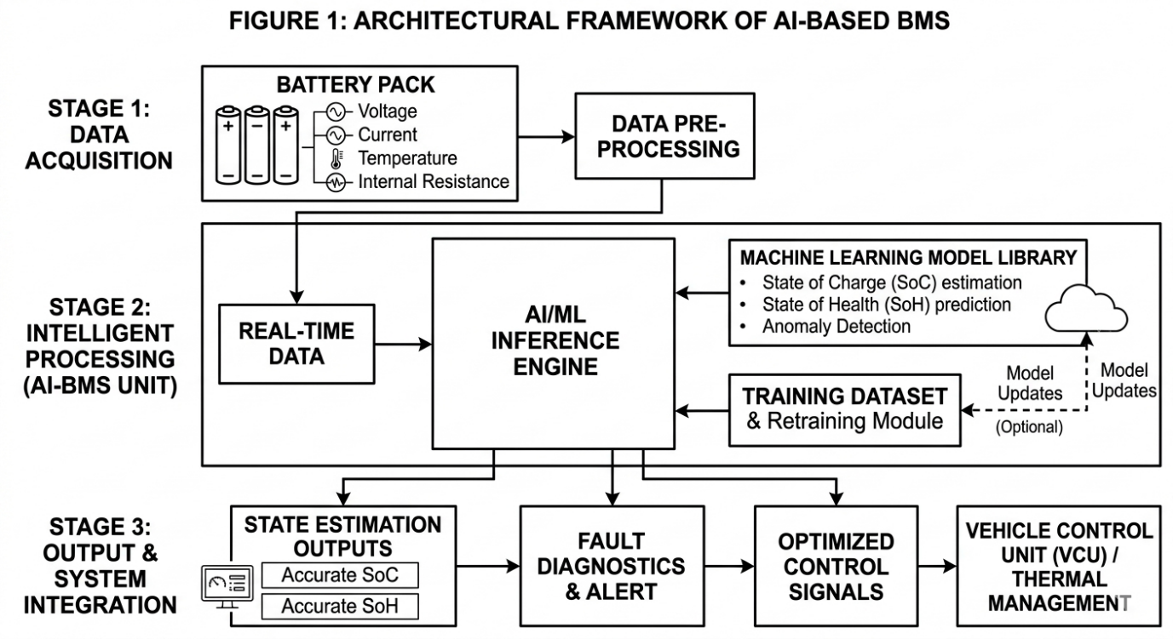Figure 5: Artificial Intelligence Based Battery Management System for Electric Vehicles
Figure 5 illustrates the architecture of an AI-based battery management system in electric vehicles. The system collects real-time data from battery sensors and manages it utilizing machine learning algorithms to approximate battery state-of-charge, state-of-health, and optimize charging cycles. This intelligent tracking system improves battery lifespan, enhances energy productivity, and guarantees safe operation of electric vehicle battery packs.

Global Electric Vehicle Market Trends
The worldwide electric vehicle market has experienced notable development in latest years.
Key statistics contain:
- EV sales exceeded 14 million units in 2023.
- EVs represented 18% of worldwide car sales.
- Over 4 million public charging stations exist globally.
- EVs generate 50–70% fewer lifecycle CO₂ emissions than traditional vehicles.
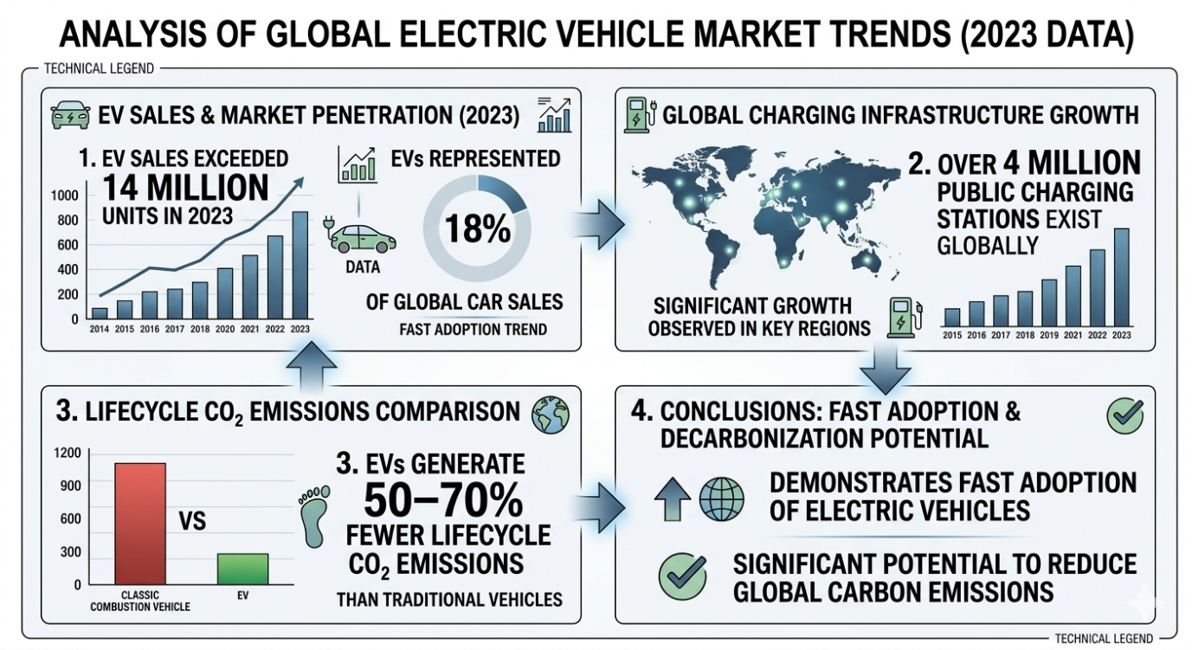Figure 6: Growth of Global Electric Vehicle Charging Infrastructure

Figure 6 illustrates the rapid growth of global electric vehicle charging infrastructure, which plays a crucial role in supporting the increasing adoption of electric vehicles worldwide.
These trends demonstrate the fast adoption of electric vehicles and their potential to reduce worldwide carbon emissions.

Electric Vehicle Industry Outlook: India VS World (2026)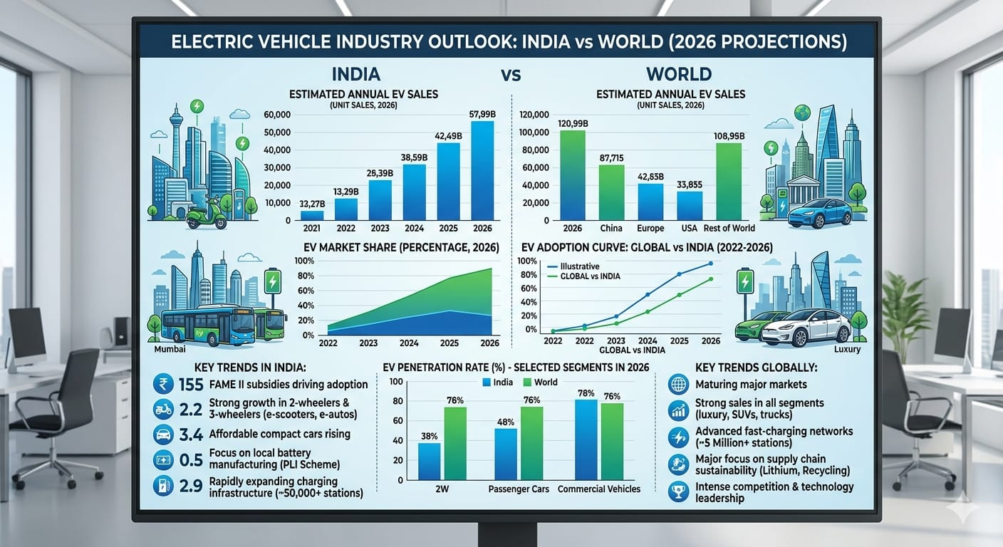Figure 7: Current Scenario of EV in India vs World

Challenges in Electric Vehicle Adoption
Despite quick development, various difficulties still restrict extensive and prevalent adoption of electric vehicles:
1.Limited charging system in several regions
2.High first cost of EVs
3.Battery deterioration over time
4.Long charging times compared to fuel refilling
5.Limited availability of crucial battery materials
6.Recycling and disposal of used batteries
Researchers are working on new battery chemistries and recycling technologies to address these problems.

Future Scope of AI-Driven Electric Vehicles
The integration of artificial intelligence with electric vehicles will play a vital role in forming the future of transportation. Future developments may contain:
- Fully autonomous electric vehicles
- AI-based smart transportation systems
- Vehicle-to-Grid (V2 G) energy systems
- Intelligent traffic management systems
- Integration with renewable energy grids
Emerging battery technologies such as sodium-ion and solid-state batteries are furthermore expected to improve EV performance and reduce costs.

Conclusion
Electric vehicles have evolved substantially over the past century, shifting from initial experimental vehicles to advanced intelligent transportation systems. Technological advancements in battery systems, electric motors, and charging system have accelerated the adoption of EVs internationally.
Artificial intelligence has become a fundamental enabler of modern electric vehicle technology. AI-based systems enhance battery performance, optimize energy consumption, and allow autonomous driving abilities. These technologies enhance vehicle productivity, safety, and dependability.
The integration of artificial intelligence with electric vehicle technology will play a crucial role in the development of future smart mobility systems. As inquiry and innovation continue, EVs is expected to become the primary and principal mode of transportation in the approaching decades, contributing considerably to worldwide sustainability and environmental protection.

REFERENCES
1. Mehrdad Ehsani, Yimin Gao, Ali Emadi, Modern Electric, Hybrid Electric, and Fuel Cell Vehicles: Fundamentals, Theory, and Design, CRC Press, 2018.
2. Iqbal Husain, Electric and Hybrid Vehicles: Design Fundamentals, 2nd ed., CRC Press, 2011.
3. James Larminie and John Lowry, Electric Vehicle Technology Explained, Wiley, 2012.
4. Giorgio Rizzoni, Fundamentals of Hybrid Electric Vehicle Systems, SAE International, 2007.
5. Chris Mi, M. Abul Masrur, and David Wenzhong Gao, Hybrid Electric Vehicles: Principles and Applications, Wiley-IEEE Press, 2011.
6. John B. Goodenough and Kyu-Young Park, “The Li-ion Rechargeable Battery: A Perspective,” Journal of the American Chemical Society, 2013.
7. Michael A. Cusumano, “The Business of Electric Vehicles,” Communications of the ACM, 2021.
8. International Energy Agency, Global EV Outlook 2024, Paris, 2024.
9. International Council on Clean Transportation, Global Electric Vehicle Market Report, Washington DC, 2023.
10. BloombergNEF, Electric Vehicle Outlook 2024, Bloomberg Finance L.P., 2024.
11. World Economic Forum, Electric Vehicles for Smart Cities Report, Geneva, 2023.
12. McKinsey & Company, The Future of Electric Mobility, Global Mobility Report, 2023.
13. U.S. Department of Energy, Battery Technologies for Electric Vehicles, DOE Energy Report, 2022.
14. MIT Energy Initiative, The Future of Electric Vehicles, Massachusetts Institute of Technology, 2019.
15. Nature Energy, “Advances in Lithium-Ion Battery Technology for Electric Vehicles,” Nature Energy Journal, vol. 5, 2020.
16. IEEE, “Artificial Intelligence Applications in Electric Vehicles,” IEEE Transactions on Intelligent Transportation Systems, 2022.
17. European Commission, Artificial Intelligence in Smart Mobility Systems, EU Research Publication, 2022.
18. SAE International, Electric Vehicle Charging Infrastructure Standards, SAE Technical Papers, 2023.
19. International Renewable Energy Agency, Global Energy Transformation Report, 2023.
20. National Renewable Energy Laboratory, Electric Vehicle Charging Infrastructure Analysis, NREL Report, 2022.
21. World Bank, Electric Mobility and Sustainable Transportation Report, 2023.
22. International Transport Forum, Global Electric Mobility Outlook, OECD Publishing, 2022.
23. Energy Storage Association, Battery Storage Technology Report, 2022.
24. Tesla, Electric Vehicle Technology Overview, Tesla Technical White Paper, 2022.
25. Toyota, Future Electric Mobility Strategy, Toyota Motor Corporation Report, 2023.
26. Nissan, Electric Vehicle Battery Technology Report, Nissan Technical Publications, 2022.
27. International Journal of Electric and Hybrid Vehicles, “AI-Based Energy Management Systems in EVs,” 2021.
28. Journal of Power Sources, “Battery Degradation and Performance in Electric Vehicles,” 2020.
29. Transportation Research Part C, “Artificial Intelligence for Autonomous Electric Vehicles,” 2021.
30. ScienceDirect, “Machine Learning Applications in Electric Vehicle Battery Management,” 2022.

